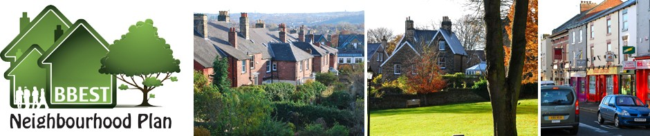 BBEST Annual Report 2014
October 2014
A brief report on Neighbourhood Planning Forum work in 2014.

FINANCE
The income over the past year has been £6,300.00 from Locality (Any unused funds will be returned in January 2015)
Last Year
The BBEST Neighbourhood forum has been very frugal over the past year, only spending £338.58 on unavoidable running costs. Knowing that there are limited funds the forum has endeavoured to spend wisely and maximise the value and impact of these small funds. The hard work, clear communication and dedication of members has minimised the reliance on training programmes and consultancy that other neighbourhood forums have had to incur. Furthermore, engaging with the students union and the local community to take an active role in such areas as assisting with housing surveys has also helped keep costs to a minimum, thank you.

To 31 December 2014
The BBEST Neighbourhood forum is facing one of their biggest challenges to date. The Grant provided late March 2013 expires in 31 December 2014 and any funds not used will have to be returned. The forum had hoped that this deadline could be extended, especially considering the delays with the designation, but unfortunately this is not possible. Given the situation the forum remains committed to ensure that we maximise value and impact of the grant. Careful consideration will have to be made to what is achievable given the short timescale. The forum will be required to submit a grant plan amendment request to enable us to carry out the revised spending plan.

1 January 2015 and beyond
Given the lack of grant support voluntary contributions and possible fund raising activities will be key to the success of the final phase of the production of the Neighbourhood plan.
In summary, we have been responsible and frugal, but are likely to be seriously short of money in 2015 … there is not likely to be any income from Locality, and BBEST will struggle to pay for meeting rooms, materials (such as printed papers) and indeed for the cost of running a website. Charging membership fees for 2015 would be a way to raise income, but at present we do not want to do this, and we are encouraging voluntary donations.

CO-ORDINATION AND DEVELOPMENT
Steering Group has met on a monthly basis. The Group has worked hard to develop the ‘infrastructure’ to get the Neighbourhood Planning process off the ground, with (applications to the Council, consideration of key evidence areas eg census, housing survey), and mechanisms for developing key themes (see task groups below). In 2015 the group’s main role will be co-ordination of the work of the task groups
Members of the Group are: Peter Marsh (Chair), Anne Daw (Vice-Chair), Chris Topliss (Treasurer), Kath O’Donovan (Secretary), Alan Wellings, Bernard Donnelly, Laure Astill, Ally Buckle (University of Sheffield Union of Students representative), Shaffaq Mohammed/Brian Webster (Cllrs)
Steering Group welcomed the attendance of several different members during the year, some of whom attended meetings on a regular basis.

MEMBERSHIP
BBEST membership currently stands at 132, with a further 39 expressing interest in receiving information about BBEST activities. 7 people who live in Sheffield but do not live or work in the BBEST area have also expressed interest.

TASK GROUPS
In line with BBEST consultation there were five major strands of the Plan identified, and in 2014 the basis for work on these has been established to greater or lesser extent. In 2015 the groups will be very active gathering evidence and information, for major public discussions and consultations later in the year.
The Task Groups are as follows (italics represent a substantial sub-theme that has work in its own right planned for 2015)
- Active Travel
  - Environment, landscape and travel work on the ‘Boulevard’ Corridor
  - Consideration of other transport issues, including 20’s plenty and shared space
- Green spaces
  - Spaces identified.
  - Environmental Survey
- Central Retail District
  - Retail area outlined, discussions with Broomhill retail community.
  - Retailers report to Broomhill Forum
  - Library/Community Hub
- Sustained and balanced communities
  - Census and demographic data
  - Housing survey. The survey will identify the housing stock, population range and density in the BBEST area and encourage ideas and engagement. A pilot project was carried out. Remaining areas will be surveyed in Autmn/Winter 2014.
- Architecture and Conservation
  - Presentations and photos
  - Design Guide development beginning with foundation work from students from School of Architecture

KEY EVENTS
On Saturday, June 14th at the Broomhill Festival Garden Party a drop-in event with activities suitable for all ages gathered expert knowledge of the area along with ideas and visions for future development. On Sunday, June 15th a talk entitled ‘Visions of Broomhill from 1800-2100: a Review and Debate.’ by Professor Prue Chiles led to lively debate, and is being followed up at the AGM and via the development of the design guide. On July 12th a model of engagement with local schools was piloted very successfully at Broomhill Infant School Fair. On 12th September a visit from Sarah Benioff, Director of Integration and Community Rights, at the Department of Communities and Local Government, looked at our substantial and continuing work with University Academic Departments and the Students’ Union.

THE NEXT TWELVE MONTHS
Most of 2015 will be continuing active engagement and consultation, and in particular development of evidence, with some draft elements of the plan beginning to emerge towards the end of the year.

Professor Peter Marsh, Chair
Anne Daw, Vice Chair
Chris Topliss, Treasurer
Kath O’Donovan, Secretary

